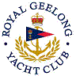 | Royal Geelong Yacht Club Inc.  Est 1859
Trophy Deed of Gift.

Trophy: | Cutty Sark
Presented by: | Darryl Clark and Ian Watson
Date: | 1981
For: | Division 1 Sub-series of Nominated Events
Remarks / Revisions
Click here for a list of Recipients

